“When people say that ‘the children are the future,’ they aren’t talking about me.”
— Jonathan Murray, 12,
Evanston, Virginia

CHAPTER 1

Ordinary. Normal. Average. Unexceptional.
Awful words: the whole lot of them. Why, just saying them can turn a mouth sour! An exaggeration? Absolutely not. To be an ordinary, normal, average, unexceptional child in a world that celebrates first place, the best, top of the class, and so on is tantamount to being invisible. It’s the human equivalent of wallpaper, someone who just blends into the background. So who would have ever imagined that two ordinary, normal, average, and highly unexceptional children would be tasked with saving the country after the greatest security breach in history?

OCTOBER 14, 7:45 A.M. MCLEAN, VIRGINIA
“There is no way a trained seal could do my job!” Arthur Pelton huffed at his wife, Franny, while fastening the shiny brass buckles on his uniform. A size too small, the navy-blue suit covered Arthur’s meatball-esque figure so tightly that it cut off a significant amount of oxygen to his extremities, leaving his face, hands, and feet perpetually pink and puffy.
“A trained orangutan or a monkey, maybe. But a seal? Never!” Arthur continued as he furrowed his brow with frustration.
“You sit on a stool and point at a sign all day. I’m pretty sure a seal could do that,” Franny replied, stifling a yawn.
“Seals have flippers, not fingers. They couldn’t point even if they wanted to. And believe me, they don’t want to!” Arthur shouted as he stormed out the front door.
Whether from anger or the physical exertion of slamming the door, Arthur had to pause on the front stoop to wipe his perspiring brow. His stubby little fingers scooped the sweat from his forehead and smoothed it across his thinning salt-and-pepper locks. Not that he was thinking about his thinning hair or propensity for perspiration. Arthur was still stuck on seals. How did he know seals didn’t want to point? Maybe they did. And now that he thought of it, they could motion toward the sign, which was kind of like pointing. Franny was right. A seal could do his job.
Arthur’s face dropped; his jowls sagged and his eyes closed. Total devastation. But then a smile slowly emerged as he reviewed the basics of his job. He worked the guard booth at an out‑of‑use delivery gate. But he didn’t just point at the sign in the window, which stated that the gate was “no longer in service,” any time a car or person approached. He also sat on a stool. How would the seal get onto the stool? Seals can’t climb. They don’t even have legs!
Arthur was not an intelligent man. Reading the ingredients on a box of crackers exhausted him. Counting was an activity that still required the use of his fingers. Needless to say, it was nothing short of a miracle that Arthur had a job. And not just any job, but a job protecting the president of the United States of America. Or so he claimed. In reality a cavalry of highly trained Secret Service agents protected the president, and Arthur manned a defunct delivery gate located on the west side of the White House.

OCTOBER 14, 11:07 A.M. THE WHITE HOUSE.
WASHINGTON, DC
“Excuse me.” A steely yet high-pitched voice jolted Arthur from what appeared to be a nap.
“I wasn’t sleeping! I just have really bad posture!” Arthur blurted out as he turned toward the voice.
Standing at the booth’s window in oversized sunglasses, a trench coat with the collar turned up, and a baseball cap was a very tiny man. So tiny that Arthur couldn’t help but wonder if he was tall enough to ride a roller coaster. Or drive a car. Surely he couldn’t see over the wheel. Unless, of course, he has a specially equipped car, Arthur mused as the short-statured man stared at him. At least Arthur assumed he was staring at him. It was rather hard to tell where the man’s eyes were focused behind his baseball cap and sunglasses.

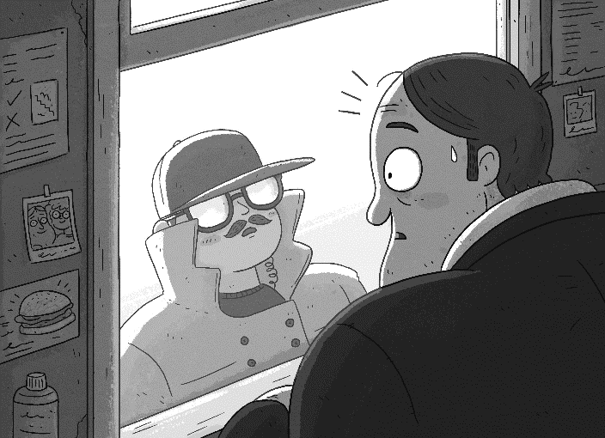

Arthur nodded his head ever so slightly as he mulled over a new idea. “Have you just come from the eye doctor? Because they’re not supposed to let you leave unless someone picks you up. You probably can’t see a thing. Do you even know where you are?”
The small man stood completely still as he continued to look in Arthur’s general direction.
“I said, do you know where you are?” Arthur repeated in a slow and deliberate fashion, all the while clenching his jaw. “Oh, I get it: Mr. Important doesn’t want to talk to a boring old security guard. What are you, some kind of really short celebrity? Man, do I hate celebrities! I remember this one time—”
The tiny man interrupted, “I am not a really short celebrity. And to answer your question, yes, I know where I am, Mr. Pelton.”
Arthur paused.
He opened his mouth.
He closed his mouth.
He narrowed his eyes.
“How do you know my name?”
“This, Mr. Pelton, is my house. I know everyone’s names.”
“Man, you are seriously lost. This is the White
House, like where the president lives,” Arthur answered with a smirk, motioning toward the large white structure behind him.
“Mr. Pelton, I am with the Secret Service. Or rather, I run the Secret Service, which means I run the White House, which means this is my house.”
Arthur shrugged. “I guess that’s kind of true. . . .”
“The truth doesn’t come in kind ofs, Mr. Pelton. Things are either true or false. Those are the only options,” the tiny man barked. “Moving on, I am here today because the Secret Service needs your help.”
“I’m in!” Arthur squealed before even hearing what the man had in mind.
We will be conducting a training mission tonight at nineteen hundred hours. And as such, we will require your assistance in accessing the west perimeter of the White House.”
“Nineteen hundred hours,” Arthur repeated as he counted on his fingers.
“Seven p.m., Mr. Pelton. Nineteen hundred hours is also known as seven p.m.”
“I knew that.”
Arthur Pelton most definitely did not know that.
“Until tonight,” the tiny man said, and then turned to leave. “Oh, and, Mr. Pelton, they don’t call us the Secret Service for nothing. You are not to tell a soul about this. Not. One. Soul.”

OCTOBER 14, 6:57 P.M. THE WHITE HOUSE.
WASHINGTON, DC
A heavy fog hung low over the capital, obscuring the tops of trees and a large portion of the district’s monuments. The soft sound of classical music emanated from the White House. Arthur stuffed tissues in his ears as he bemoaned the yearly visit of the
Metropolitan Children’s Philharmonic, currently playing for an audience that included the president, the vice president, and the secretary of state.
Tap, tap, tap.
Arthur yelped (of course he did; that’s what his wife, Franny, would have said).
The short-statured man from the Secret Service, whose face was once again obscured by a baseball cap, stood at the booth’s window.
“I had to put tissues in my ears because of the—”
“The Met Chil Phil. They’re nothing but a bunch of ingrates,” the man interrupted. “Now on to business.” He then pointed to the gate, followed by a keypad on the wall next to Arthur. But Arthur didn’t move. He just sat there, utterly paralyzed. He had never opened the gate; it had been out of service long before he had even started working at the White House.
“Mr. Pelton,” the man from the Secret Service said as sweat dripped steadily from Arthur’s brow.
This was his big moment, Arthur’s one chance to shine. And yet he couldn’t remember the code, which had been given to him on the off chance that an emergency might warrant opening the gate.
The small man’s voice grew louder, cutting sharply through the brisk air. “Is there a problem, Mr. Pelton?”
And then, as if by magic, Arthur remembered the code, punched in the numbers, and smiled excitedly.
“Good luck—or do you guys not say that in your business? How about knock ’em dead? Or break a leg?” Arthur babbled, prompting the man to twirl his hand dramatically in the air.
“What’s that about? You pretending to be one of those fancy guys who waves a stick at musicians?”
Arthur grumbled as the man from the Secret Service disappeared into the night.

✶ ✶ ✶

Within hours, the vice president of the United States had been kidnapped. The nation’s greatest group of spies deactivated. And one of two codes necessary to access the government’s mainframe, which housed classified documents belonging to the White House, the Department of Justice, the FBI, and the CIA, had been stolen. And all because Arthur Pelton wanted to prove that he wasn’t just some nobody doing a job that even a trained seal could handle.

“How dare you say I’m underperforming!? Everyone knows that the real problem is that the others are overperforming!.”
— Sally Jenkins, 11,
Little Rock, Arkansas

CHAPTER 2

There’s an old adage that everyone has a story. However, nowhere does it say that everyone has an interesting story. Twelve-year-old Jonathan Murray did not have an interesting story. And he knew it. Every morning he looked in the mirror and thought, This is it. This is what I’m stuck with. He was average, middle‑of‑the-road, and pedestrian in every way that the world deemed relevant— academically, athletically, socially, and so on. Even his appearance— nondescript black hair that clung to his forehead as if it were in danger of falling off and thick eyebrows— was utterly normal, neither attractive nor unattractive. But none of this surprised Jonathan, for long ago, or as long ago as a twelve-year-old can remember, he had accepted his fate. Nothing was ever going to change. Or so he thought.

OCTOBER 15, 6:58 A.M. EVANSTON, VIRGINIA
It was fast approaching seven a.m. and the sky was still a dull gray. Rain clouds lingered in the distance. The sun, heavily muted, cast a dim, almost candle-like light. Shadows lurked about the ground, crawling from one house to the next. It was quiet. Not even a bird chirped. This was not by accident, but rather due to Evanston’s city ordinance on irksome sounds—officially called “noise pollution”—which included everything from chirpy birds to whistling in the street to poorly tuned cars. Of course, regulating birds was nowhere near as easy as regulating cars and people who whistled, but Evanston’s Community Patrol found a way. They always found a way. And in this particular case “finding a way” meant introducing laryngitis to the bird population, leaving them incapable of chirping any louder than a whisper.
Located just across the Potomac River from Washington, DC, Evanston was well known for its precision. Gardeners regularly measured grass strands to maintain uniform lawn heights. Sprinklers ran counterclockwise at eight a.m. and clockwise at nine p.m. It was a town of doers, of overachievers, of goal-oriented people. Parents groomed children from birth to excel not only academically but athletically, musically, linguistically, philanthropically, extracurricularly, and so on. It was for this reason that 98.5 percent of Evanston High School’s last graduating class went on to Ivy League universities. The remaining 1.5 percent fled abroad to avoid bringing further shame to their families. Bottom line: Evanston was an uptight town.
So it was quite a surprise—a shock really—when on the morning of October 15 at 6:58 a.m., a garbage truck sputtered and clunked (a direct violation of the city’s noise ordinance) down Forrester Lane. It stopped in front of number sixteen, the lone eyesore on the block. Broken-down bicycles littered the lawn. The once white picket fence was now gray and pretty much picket-less. The house was painted half yellow and half green, not by design, but rather laziness. That’s right, the inhabitants had lost interest in their home improvement project halfway through, stopping without even bothering to put away the ladder, bucket, or paintbrush. Pinned to the front door was a wad of fading notices from Evanston’s Community Patrol asking the inhabitants to please tidy up or else they would have no choice but to leave another note. (Full disclosure: Evanston’s Community Patrol was an all-volunteer group with no legal standing.)
Sleeping soundly, tucked beneath plain white sheets, in his room on the second story of number sixteen Forrester Lane was Jonathan Murray. It was a dreary room with little in the way of personal items. A calendar from the local dry cleaner hung over the bed. The thick shag carpet, while lean, was a drab shade of brown that matched the curtains. The bedside table contained an old alarm clock and a hairbrush, nothing more. And it was here, amid this dowdy decor, that Jonathan suddenly awoke and cocked his head to the left, much like a dog whose owner had called his name. He then pushed back the sheets, walked to the window, and sighed. Jonathan was always sighing, a result of finding himself terribly dull.
There was a garbage truck idling in front of the house. Only it wasn’t trash day, Jonathan thought, and while the truck looked like one of Evanston’s eco-friendly fleet, it didn’t sound like it. Curious, Jonathan leaned out his bedroom window and squinted down at the street. A camera with a telephoto lens was hanging out the passenger-side window snapping pictures. Why would anyone want photographs of his house, Jonathan wondered, until the appearance of a bicycle with a billowing red flag distracted him. On the bike was a Community Patrol volunteer, eager to write up the driver for both noise pollution and trash day schedule violation.
However, upon seeing the bicyclist, the driver immediately put the truck in gear and clunked away.
Never one to give up issuing a ticket without a fight, the Community Patrol volunteer popped a flashing red light on the handlebars and set off in pursuit. Still standing at the window, Jonathan turned his attention to Freddy the paperboy, who was tiptoeing up his neighbors’ driveway, carefully laying the Washington Chronicle on the doorstep.

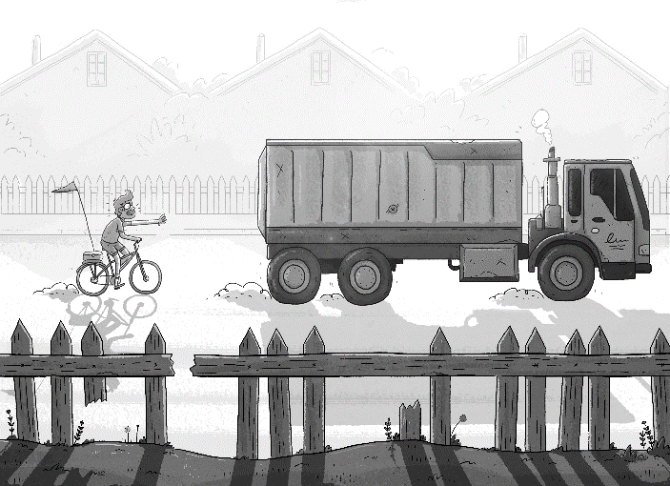

Unlike other mornings, Freddy paused and then carefully inspected the front page. Although Jonathan couldn’t see what had piqued Freddy’s interest, he would later learn it was a photo of a wild-eyed man with a six-inch gray Afro shoving a cookie into his mouth, alongside the headline: “Real-Life Cookie Monster Faces 100 Years in Jail.”
The sound of giggling, Jonathan’s parents’ giggling to be precise, drifted into his room, reminding him that it was a school day. Jonathan then showered, put on his standard outfit of khakis and a sensible sweater, and headed down to the kitchen. Posters of rock bands lined the hallway, each taped or pinned haphazardly, keeping them consistently crooked. At the foot of the stairs, an arcade-sized Pac-Man game and a popcorn machine framed the entryway to the kitchen, aka the comic book library.
There were literally stacks of old editions stored in the oven, freezer, and pantry.
“There he is! Our favorite child!” Mickey Murray called out as Jonathan entered the kitchen.
Mickey had the appearance of a skateboarder or a surfer, with blond windswept hair, a honey-colored tan, and a getup that included both swim shorts and sandals.
“Well, if it isn’t our number one son!” dark-haired and olive-skinned
Carmen Murray hollered in her thick Mexican accent, pumping her arms in the air as if performing a well-orchestrated routine.
Petite and smiley, Carmen still bore a striking resemblance, both physically and mentally, to the cheerleader she had once been. And while Jonathan liked cheerleaders well enough, he sometimes found his mother’s optimistic approach to life bordering on delusional.
“I don’t mean to sound ungrateful, but being ‘number one’ or your ‘favorite’ child isn’t much of an accomplishment when there’s only one kid. I mean, there’s not even a dog to compete against,” Jonathan grumbled as he picked up empty bags of chips and tossed them into the trash can.
“You want a dog? I can get you a dog. Old Lady Preston can’t even remember how many she has; we can take one off her hands easily,” Mickey declared confidently.
“Dad, petnapping is illegal,” Jonathan muttered, and then sighed. “Why are you guys up so early?”
“All-night horror fest on channel 563. It was awesome. Zombies, zombies, and more zombies,” Mickey said, and then swigged a big gulp of milk straight from the carton.
“Hey,” Carmen said as she tapped Mickey’s arm. “What did I say about the milk?” “To leave some for you. My bad, babe.” “It’s all good,” Carmen said with a wink as Jonathan inwardly cringed.
Why did his mom and dad feel the need to talk like this? The other parents in Evanston didn’t use expressions like “it’s all good” and “my bad.” No, the other mothers and fathers were adults, and as such they peppered their speech with dignified phrases like “to the best of my knowledge” and “with all due respect.”
Jonathan grabbed his lunch from the refrigerator and halfheartedly waved good-​bye to his parents. “Well, I’m off to school.”
“Not so fast. We need to talk about that report card,” Carmen said in a serious tone. “Way!! To!! Go!!!”
“Mom, I got straight Cs.”
“And we’re darn proud of you for it,” Mickey said, saluting his son.
“You guys really need to raise your standards,” Jonathan moaned. “I’m pretty sure this is how you wound up at a university whose acceptance policy consists of dialing a 1‑800 number.”
Mickey and Carmen Murray were fine and decent people. They just happened to have never really grown up; they were stranded at sixteen— permanently. They thought that dog walking was a career. They never voted. They sort of paid taxes. They referred to Max Arons, the president of the United States, as the Boss Man because they couldn’t remember his name. They did their grocery shopping at 7‑Eleven. But they loved their son. And that was all that mattered, according to a fortune cookie they once read.
Jonathan pulled on his backpack and exited the house at exactly 8:15 a.m., the time when all Evanstonian students were encouraged by the Community Patrol to depart so as to avoid tardiness. Jonathan nodded hello to his neighbor’s ancient pug, sunbathing on the lawn, and then turned onto the sidewalk next to a tall, athletic boy in a letterman jacket.
“Good morning, Tom,” Jonathan offered flatly.
“Oh, hey! You must be that new kid my mom was telling me about. Welcome to Evanston. You’re going to love it here. Especially if you play ice hockey, number one in the nation four years running,” Tom said, and then pointed to one of many shiny gold pins on his jacket.
Jonathan brushed away the hair on his forehead and rolled his eyes. Some things never changed. “Tom, it’s me, Jonathan Murray. We’ve lived three doors down from each other our whole lives. Your sister Cathy once babysat me. It was kind of a big deal. She lost me at the mall and then took home some other kid because she couldn’t remember what I looked like.”
“No way! That was you? Crazy! Well, see you around, Jeff,” Tom replied, and then disappeared into the herd of students crowding the sidewalk.
This was the story of Jonathan’s life. No one ever noticed him, so he could hardly be surprised when they failed to remember him. He was white rice, there but never focused on. And yet as Jonathan puttered along at the tail end of the mass of students, he heard footsteps behind him. Steps that mimicked his own, starting and stopping just as
Jonathan did. He shook his head, certain that it was a case of mistaken identity. For no one would ever purposely follow Jonathan Murray. Eager to educate the misguided stalker, Jonathan turned around and scanned the street behind him. But there wasn’t a soul in sight.
And so the boy continued on his way, unnerved by the sensation that someone was watching him, paying attention to his every move.

